**Exercise 1**



Class:

Dog

Properties:

Breed

Colour

Size

Behavior:

Sit()

Run()

Jump()

Breed: Maltese

Colour: White

Size: Small

Breed: Golden Retriever

Colour: Gold

Size: Large

Breed: Poodle

Colour: Brown

Size: Small

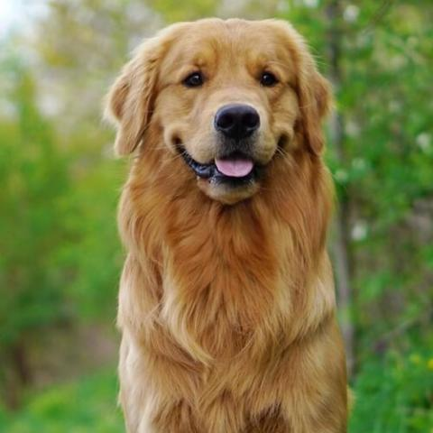 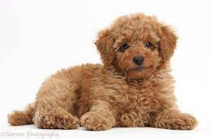 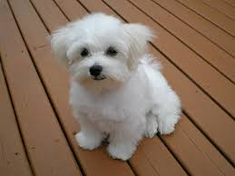



Behavior:

Eat()

Sleep()

Jump()

Properties:

Breed

Colour

Size

Class:

Rabbit

Breed: American Rabbit

Colour: Blue

Size: Medium

Breed: Holland Lop Rabbit

Colour: Chestnut

Size: Small

Breed: Flemish Giant Rabbit

Colour: Fawn

Size: Large

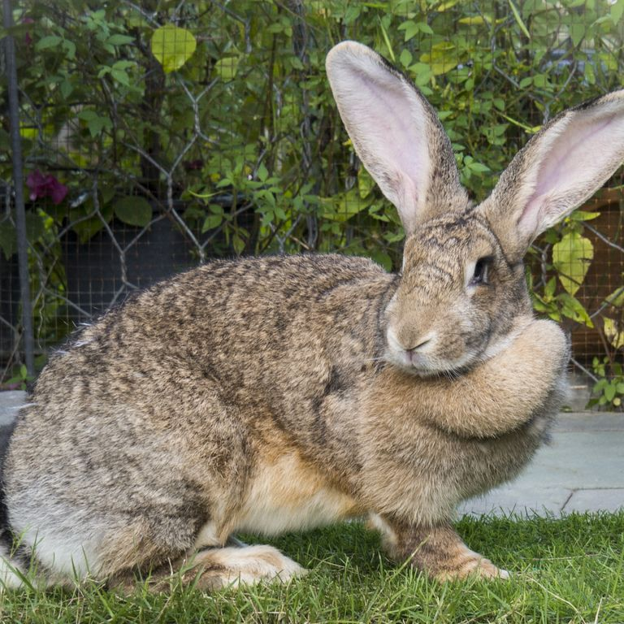 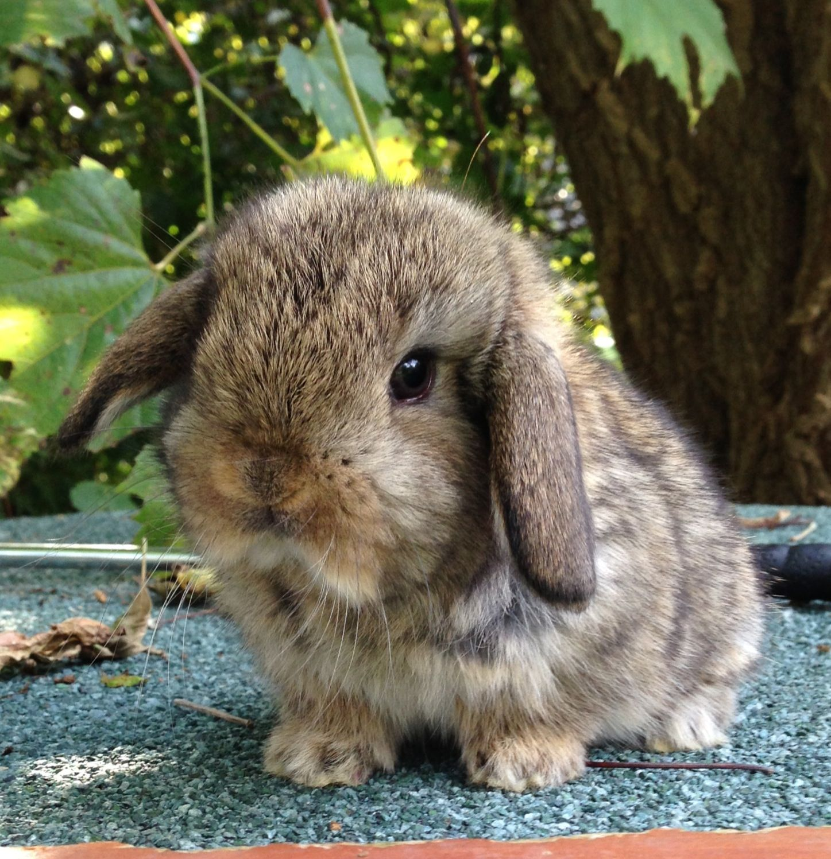 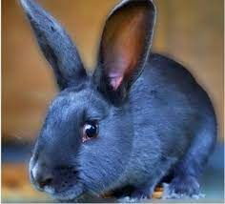



Brand: Samsung

Model: UN50TU7000FXZA

Screen: LCD

Brand: Sharp

Model: 4TC50AH8X

Screen: LED

Behavior:

Youtube()

Browser()

Share screen()

Properties:

Brand

Model

Screen

Class:

Smart Television

Brand: Panasonic

Model: TH-65HZ1500K

Screen: OLED

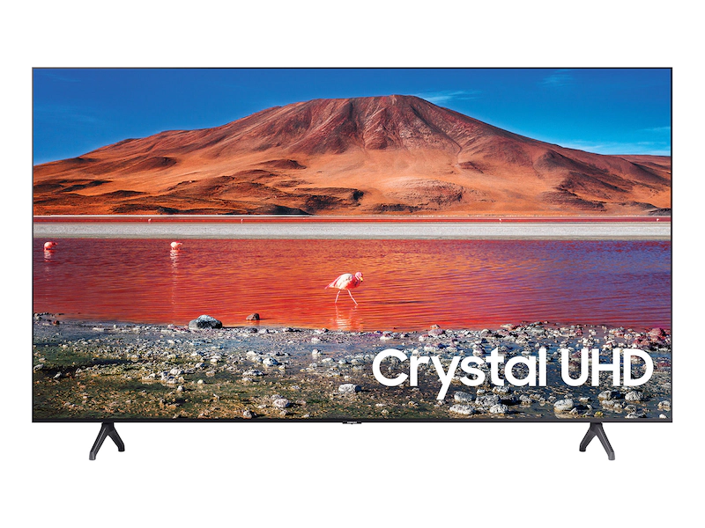 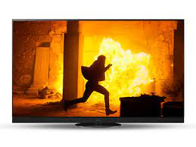 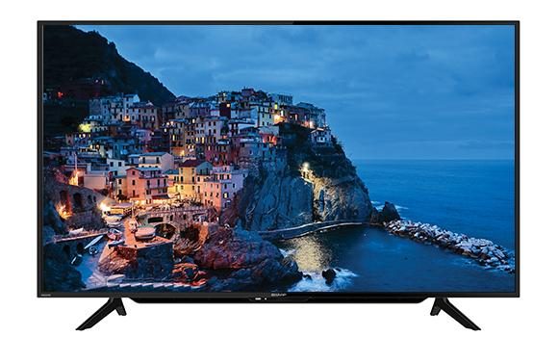



Class:

Oven

Properties:

Brand

Model

Capacity

Behavior:

Grill()

Defrost()

Lamp()

Brand: Panasonic

Model: NU-SC100WMPQ

Capacitty: 15L

Brand: Khind

Model: OT23B

Capacitty: 23L

Brand: Elba

Model: EEO-J4591D(BK)

Capacitty: 45L

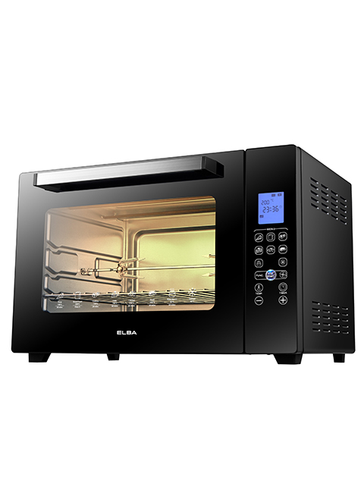 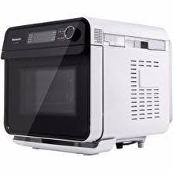 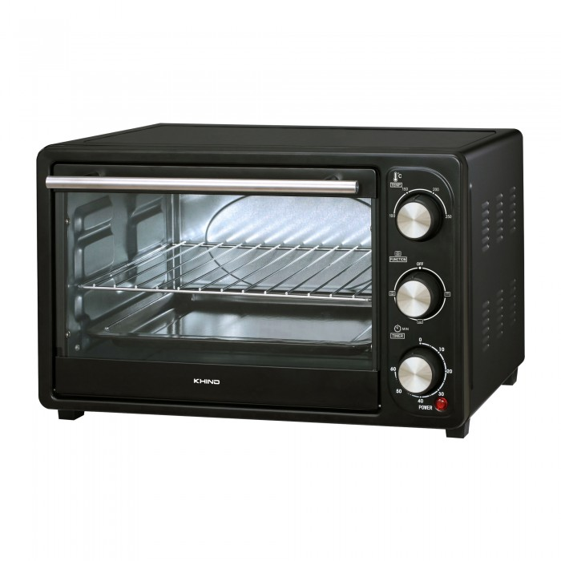



Brand: Coway

Model: CHP-264L

Child safety lock: Yes

Brand: LG

Model: WD512AN

Child safety lock: Yes

Behavior:

Hot water()

Ambient water()

Cold water()

Properties:

Brand

Model

Child safety lock

Class:

Water Purifier

Brand: Cuckoo

Model: VIVID

Child safety lock: Yes

